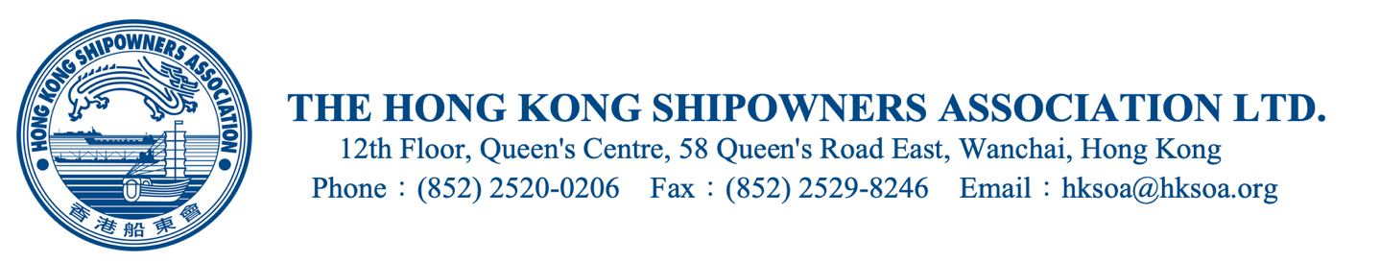

CONFIDENTIAL
Cir. Ref: O(24)01

TO ALL ORDINARY MEMBERS 2 January 2024

Dear Ma’am/Sir,

Members’ Collective Fleet and Annual Statistics for 2023

We would be very grateful if you could please complete and return the attached reply forms in order to provide us with details of the vessels presently owned, operated, managed or crewed by your Company as of 31 December 2023. In order to improve efficiency and accuracy when we transfer the collected data into our database, members are kindly requested to return the softcopy of the forms to us by email.

The collected data is required by the Association to determine the composition of our collective fleet and how to target our services to our members more effectively. Information supplied will be kept totally confidential and will not be divulged on an individual basis. Only the usual total tonnage figures and summaries will be released outside the Association.

You are requested to study the various notes attached before you fill in the forms.

We would very much appreciate it if you would kindly return your completed forms to us by 31 January 2024.

My best regards

Nittin Handa
Director - Regulatory Affairs

Encl.

THE HONG KONG SHIPOWNERS ASSOCIATION

Members’ Collective Fleet and Annual Statistics for 2023
(For this section, in the excel sheet, please complete form in the tab “V&T input”)
Explanatory Notes:
- This survey will be similar to the one made last year, in that we would like to be able to identify those ships ‘Owned’ in Hong Kong (“O”), those ‘Technically managed from Hong Kong (“T”) and those for which the ‘Crew is managed’ from Hong Kong (“C”). Any combination of these notations is possible, so that if a ship is ‘Owned’, ‘Technically managed’ and ‘Crew managed’ by your Company, it would be rated with all three notations ‘O’, ‘T’ and ‘C’.
- A ship for which the Crew is managed from Hong Kong by your company would have the notation ‘C’. Those who declare ‘C’ for any ship or ships are also requested to complete the Survey on the Nationality of Crew and Officers.
- For each ship you declare there should be at least a single notation. This means that duplicates or triplicates may exist in our records, since two or three companies may declare the same ship.
- “Ownership’ is a flexible concept, so when declaring whether a ship is ‘Owned’, in Hong Kong, we would appreciate the declaration of all ships for which the control of ownership is exercised in Hong Kong, whether beneficially owned here or not.
- As an Association, it is important that we have this data for analysis and would ask you to contact us if you have problems with the completion of this survey.
- We would be very grateful if you would use the pre-defined types of ship, wherever possible.
- Should this survey not apply to your present status, a Nil return would be much appreciated.

THE HONG KONG SHIPOWNERS ASSOCIATION

PREDEFINED LIST OF SHIP TYPES

Bulk Carrier

Cement Carrier

Container Ship

Dredger/Hopper Dredger

Floating Storage

Gas Carrier (LNG)

Gas Carrier (LPG)

General Cargo

Heavy Lift/Project Cargo

Livestock Carrier

Motor Launch

Multi-Purpose Vessel

OBO

OSV/Tug

Passenger/Cruise/Ferry

PCTC/Ro-Ro/Car Carrier

Reefer

Tanker

Tanker (Chemical)

Tanker (Product)

Woodchip Carrier

Others
THE HONG KONG SHIPOWNERS ASSOCIATION
2023 SURVEY ON THE NATIONALITY OF CREW AND OFFICERS
For completion by members who have declared their fleet to be ‘crew managed’

The nationality of crew and officers presently under our management are specified as follows (please see sample below):-
(For this section, in the excel sheet, please complete form in the tab “Crew data input”, by entering the data in the yellow cells)

Category | Total (No. in persons) | Category | Total (No. in persons)
Ratings | 475 | Officers: | 288
Nationality | Number | Nationality | Number
Filipino | 350 | Hong Kong | 3
Indian | 50 | Filipino | 125
PRC | 75 | Indian | 85
 |  | PRC | 75

