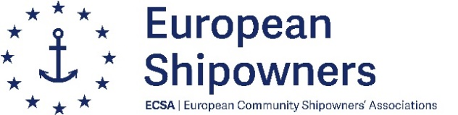

ICS and European Shipowners | ECSA welcome the Hong Kong Convention entering into force globally
- The International Chamber of Shipping (ICS) and European Shipowners | ECSA welcome the Hong Kong International Convention for the Safe and Environmentally Sound Recycling of Ships entering into force globally today.
- ICS and ES|ECSA have been advocating for the Hong Kong Convention to come into force since adoption at IMO in 2009 to ensure international safe and sustainable ship recycling processes.
- Global regulations and instruments such as the Hong Kong Convention are vital and reiterate the industry’s commitment to safe and sustainable ship recycling practices.
26 June 2025, London: The International Chamber of Shipping (ICS) and European Shipowners | ECSA welcome the Hong Kong International Convention for the Safe and Environmentally Sound Recycling of Ships (Hong Kong Convention) entering into force globally today.
The International Maritime Organization (IMO) adopted the Hong Kong Convention on the 15th May 2009. The aim of the Convention is to reduce risks to health, safety and the environment, ensuring that ships when being recycled after reaching the end of their operational lives, do not pose any unnecessary risk to human health and safety or the environment.
The International Chamber of Shipping and European Shipowners | ECSA have been advocating for the Hong Kong Convention to come into force since adoption at IMO to ensure international safe and sustainable ship recycling processes.
Thomas A. Kazakos, Secretary General of the International Chamber of Shipping, comments:
“Today marks a welcome and historical development after two decades of work on the issue. At ICS we have long been championing for safe and sustainable ship recycling practices. Now that the Hong Kong Convention has entered into force we can look forward to even more progress in improving ship recycling around the world.
As the industry pushes forward on its decarbonisation journey the lifespan of the merchant fleet is likely to reduce, through global instruments such as the Hong Kong Convention we can progress, safely, efficiently and sustainably. A global industry needs global regulations.”
Sotiris Raptis, Secretary General, European Shipowners | ECSA adds:
“The entry into force of the Hong Kong Convention is a milestone for our industry. It sends a strong signal that multilateral cooperation in IMO can and should continue to deliver. The global requirements entering into force today already represent significant progress for the sustainability of our industry. We now need to build on this foundation and further strengthen the Hong Kong Convention to raise the bar and continue to make meaningful progress towards safe and sustainable ship recycling practices. One global standard is essential to deliver environmentally sound and safe ship recycling and to ensure the competitiveness of European shipping”.

Notes to Editors:
About ICS
The International Chamber of Shipping (ICS) is the principal international trade association for merchant shipowners and operators, representing all sectors and trades and over 80% of the world merchant fleet – www.ics-shipping.org.
About European Shipowners | ECSA
European Shipowners | ECSA represents 22 national shipowners’ associations based in the EU and Norway. European shipowners control 35 % of the global commercial fleet, contribute 127.8 billion euros per year to the EU GDP and provide 1.4 million people with careers both on board and ashore. ECSA strives for a regulatory environment that fosters the international competitiveness of European shipping, to the benefit of the EU– www.ecsa.eu

