

Circular to ICS Members
Date: 14 October 2025
Subject: Supplementary Information on China's Special Port Service Fees for U.S.-Linked Vessels

Dear Members,

Further to our earlier circular dated 14 October 2025 regarding the Ministry of Transport's (MOT) implementation measures on Special Port Service Fees for U.S.-linked vessels, we would like to provide additional updates based on the following two announcements issued by the Chinese Maritime Safety Administration (MSA) and the Water Transport Bureau of MOT.

1. Submission Guidelines for the "Report on U.S.-Linked Ship Information"

The Chinese Maritime Safety Administration (MSA) has issued guidelines for submitting the 《船舶涉美信息报告表》(Reporting Form of U.S.-Linked Ship Information). Below is a summary of the submission process and requirements:

Submission Method

According to the MOT’s announcement on the collection of Special Port Service Fees for U.S.-linked vessels, shipowners or their agents must submit the Report on U.S.-Linked Ship Information along with other application materials during the inbound clearance process for international voyages.

Submission Platform:

- International Trade "Single Window"

  - Navigate to: Ship Transport Tools → Inbound Voyage Declaration → Attachment Management

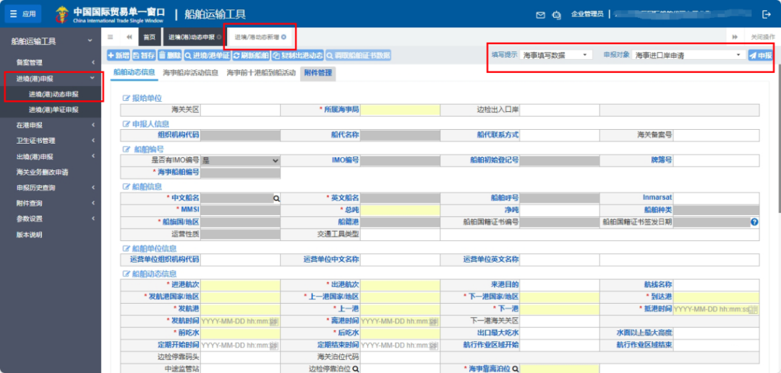
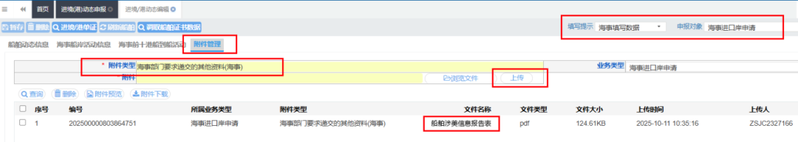

Instructions for Completing the Report

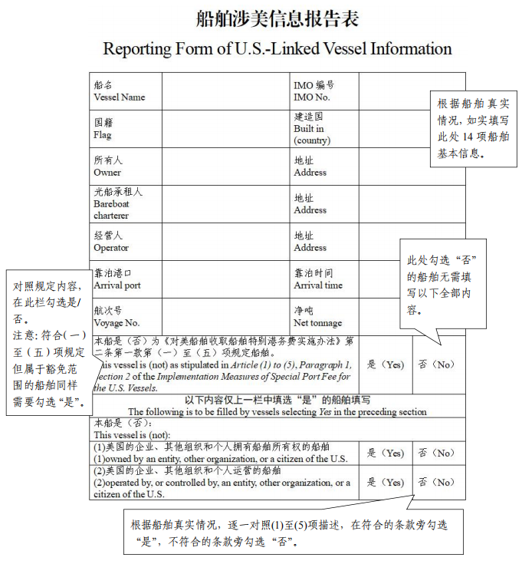

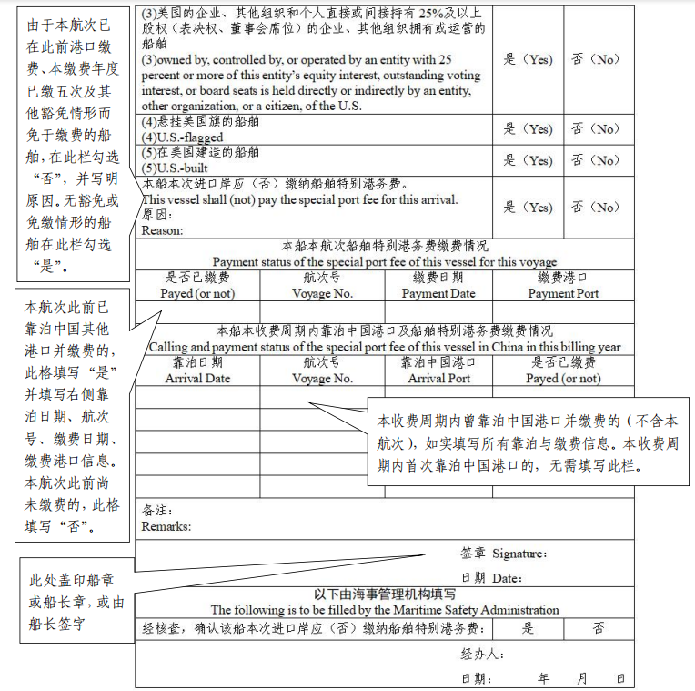

Issued by:
Maritime Safety Administration of the People’s Republic of China
Date: 14 October 2025

2. Interpretation of the Implementation Measures for Special Port Service Fees on U.S.-Linked Vessels

The Water Transport Bureau of the Ministry of Transport (MOT) has provided an official interpretation of the Implementation Measures for Special Port Service Fees on U.S.-Linked Vessels. Below are the key highlights:

Background
On 17 April 2025, the United States Trade Representative (USTR) announced Section 301 measures targeting China’s maritime, logistics, and shipbuilding industries. Starting 14 October 2025, additional port service fees were imposed on Chinese-owned, Chinese-built, and Chinese-flagged vessels. This action violates WTO rules and the U.S.-China Maritime Agreement, severely disrupting maritime trade between the two countries.

In response, and with approval from the State Council, the MOT issued an announcement to impose reciprocal Special Port Service Fees on U.S.-linked vessels. The implementation aims to protect the legitimate rights of Chinese industries and ensure fair competition in international shipping.

Key Provisions

The Implementation Measures, consisting of 10 articles, outline:

- Legal Basis: The measures are based on the Regulations on International Maritime Transportation of the PRC.

- Scope of Collection: Specifies the types of vessels subject to the fees (e.g., U.S.-owned, U.S.-operated, or U.S.-built vessels), and exemptions (e.g., China-built vessels and ballast vessels for repairs).

- Rates: Details the dynamic fee structure, with annual adjustments starting at RMB 400 per net ton.

- Reporting Requirements: Shipowners or agents must submit information to the maritime authority before arrival at Chinese ports.

- Dynamic Adjustments: The scope, rates, and effective period of the fees may be updated based on evolving circumstances.

Implementation Objectives

The measures ensure compliance with the announcement and provide operational clarity for shipowners. Members are urged to review their ownership, operational structures, and reporting obligations to mitigate risks of non-compliance.

Recommendations for Members

In light of the above announcements, members are strongly encouraged to:

- Familiarize themselves with the submission process for the Reporting Form of U.S.-Linked Ship Information and ensure timely compliance.

- Review the interpretation of the Implementation Measures and determine any implications on fleet operations, ownership, or control structures.

- Prepare all required documentation before port calls in China and consult legal or compliance advisors as necessary.

Best regards,

Edward Liu, MH
Principal Representative
ICS (China) Liaison Office & Shanghai Representative Office

