INTERTANKO GUIDANCE FOR MEMBERS
Safe Management of Vessel Transit
Through the Strait of Hormuz

IMPORTANT NOTICE. This document provides operational guidance to INTERTANKO members. It is intended to support voyage-specific risk assessment, facilitating safe shipboard and office planning. It does not replace company procedures, Master's professional judgment and overriding authority, Flag State or coastal State requirements, charterparty obligations, insurance advice, or current official naval and governmental guidance.

March 2026

1. Purpose and Scope
This guidance has been prepared to assist INTERTANKO members in planning and safely managing vessel transit into, within, or out of the Gulf region where a transit through the Strait of Hormuz may be required during periods of heightened regional security risk.

For the purpose of this guidance, transit includes:
- Repositioning for loading, discharge, lay-by, crew change, anchoring, bunkering, or other technical reasons
- Tactical delay or movement to a safer waiting area
- Onward routing through the Strait of Hormuz

The guidance is intentionally advisory. Members should adapt it to the characteristics of the vessel, the voyage, the current threat assessment, crew competence and composition, contractual requirements, Flag instructions or recommendations, insurance cover, and any other company-specific restrictions. This guidance should be read in conjunction with the latest version of the Best Management Practices for Maritime Security (BMP)

2. Guiding Principles
- Safety of life, safe navigation, and protection of environment remain the primary considerations, with Masters using their overriding authority to ensure these paramount objectives as per SOLAS
- Transit decisions should be based on a fresh, updated, voyage-specific assessment rather than on standing assumptions.
- The Master, Company Security Officer (CSO), and shore management should maintain a shared operational picture before and during transit.
- External guidance should be drawn from current official sources, including JMIC, UKMTO, MSCIO/EUNAVFOR, BMP Maritime Security, relevant naval advisories, specialist security consultants, and applicable Flag instructions.
- When security threat assessment changes materially, transit deferment should be the safer option.

2.1 INTERTANKO Position

! | INTERTANKO considers that under present circumstances transit the Strait of Hormuz should be avoided. However, following a significant de-escalation, ideally including a formal ceasefire, mine clearance, adequate naval support/overwatch or confirmed availability of warship escorts, then transits could be resumed. Notwithstanding this position, companies with vessels operating in these waters are advised to conduct a ship specific pre-voyage risk assessment, incorporate appropriate protective measures into vessel security plans, exercise heightened caution, and monitor VHF Channel 16 at all times. In the event of attack, incident, or suspicious activity, Ship Security Alert System (SSAS) should be activated and the United Kingdom Maritime Trade Office (UKMTO) and U.S. Fifth Fleet Battle Watch contacted without delay.

2.2 Surge Traffic Conditions
When a transit window opens — particularly following a period of restriction or heightened threat — the following conditions are expected to develop rapidly:

Condition | Risk Implication
Simultaneous, uncoordinated transits | Unpredictable traffic picture; chain-reaction manoeuvres
Mixed vessel size and type (VLCC to coaster to dhow) | Wide variation in stopping distances, turning circles, and reaction times. Hazardous overtaking and course changes
AIS saturation / poor CPA reliability | Overreliance on incorrect vectors; missed close-quarters development. Hindered COLREG compliance response
Erratic manoeuvring by risk-averse Masters | Unexpected course/speed alterations creating secondary conflicts
Congestion at TSS turn/merge/choke points | Forced CPA reduction; limited sea room for avoiding action. Collision risk
Reduced naval oversight bandwidth | Slower response to distress or incident; Masters must be self-reliant
Limited salvage resources in the area | Impossibility to quickly remove vessels with lost propulsion or steering/blackout out of the way to clear transit corridor

Key finding: During surge periods, collision and grounding risk historically rises faster than direct kinetic threat exposure. Both dimensions must be addressed in pre-transit planning.

3. Current Operating Context
Conditions affecting merchant shipping in and around the Strait of Hormuz can change rapidly. Members should expect a risk environment that may include kinetic threats, electronic interference, reporting uncertainty, and periods of compressed, or unpredictable, traffic flow at various speeds. AIS spoofing can be used by attackers placing fake AIS echoes in the vicinity of the courseline in an attempt to trigger course and/or speed changes desirable by the attackers.

Even when the waterway remains legally open, operational conditions may be degraded by:
- GNSS jamming or spoofing
- AIS anomalies and false target injection (AIS spoofing)
- Heavy traffic concentration and reduced decision margins within or near the Traffic Separation Scheme (TSS)
- Stress-driven maneuvering by surrounding vessels

Accordingly, transit planning must consider both security risk and navigational risk. Companies and Masters are strongly encouraged to maintain continuous situational awareness and to verify the complete threat picture immediately prior committing to transit. OCIMF publication “Loitering Munitions – The Threat to Merchant Ships” is recommended to be consulted.

4. Anchoring and Waiting Position Considerations
Vessels may need to wait for a suitable transit window, favourable naval presence, or improved security threat conditions. The selection of a waiting or drifting position requires careful risk-benefit assessment.

Factor | Closer to Port / Installations | Offshore / Open Water
Proximity to targets | Higher — near refineries, terminals | Lower — reduced target association
Counter-drone / counter-missile coverage | Potentially better — infrastructure protected by systems covering vessel | Potentially limited
Traffic density risk | Higher near port approaches | Generally lower
Evacuation/rescue access | Better shore access | Potentially slower response

The secure waiting area must be determined by the respective company in consultation with their Head of Security / CSO, in co-operation with military and local authorities as appropriate. No single position is universally safe — assessment should be voyage- and condition-specific.

5. Recommended Planning Considerations

5.1 Threat and Commercial
- Confirm the latest security threat assessment, recent incidents, and any current notices or advisories affecting the intended route.
- Review whether the SOH transit is necessary now, whether it can be delayed, or can be executed in a lower-risk time window.
- Check insurance cover and its specific extent, confirming war-risk protection, charterparty, and company escalation requirements before committing a vessel to transit

5.2 Vessel and Technical Readiness
- Review the vessel's technical resilience — navigational sensors, steering arrangements, propulsion readiness, external communications, emergency power and other redundancies.
- Ensure strict instructions exist for GNSS-compromised navigation. INTERTANKO GNSS Guidelines and ICS bridge cards are to be observed.
- Bridge teams, including lookouts, are to participate in a GNSS signal loss drill at least once before transit. Findings and lessons learned must be evaluated and addressed by the Master on board and the company DPA/Nautical Manager ashore.
- The planning assumption must be total unavailability — or unreliability — of the GNSS signal for the entirety of the transit.
- Consider the availability of salvage capability in the area. Additional coverage or resource support should be sought if required.
- Purchase paper charts as back-up for enhanced terrestrial navigation and position plotting, particularly if ECDIS is not fitted with the radar overlay. Confirm that Officers of the Watch (OOW) and the Master are proficient in position plotting on paper charts.

5.3 Crew and Manning
- Confirm crew readiness, fatigue status, anxiety, bridge crewing plan, protective measures, drills, and citadel or shelter arrangements where applicable. Check if people are willing to transit.
- Disembark non-essential personnel (trainees, cadets, shore workers, service engineers, riding squads, etc.) prior to transit.

5.4 Passage Plan and Orders
- Incorporate the transit into the berth-to-berth passage plan and Master's standing orders.
- Define entry and exit waypoints, potential choke points, recommended minimum closest point of approach (CPAs), and provide recommended coordinates.
- Provide the Master with a pre-transit guidance document and transit execution advice.

5.5 AIS and Navigational Lights Policy
- INTERTANKO recommends maintaining AIS ON during transit. Final policy decision rests with the company, with overriding authority retained by the Master as per SOLAS.
- If AIS is switched off, inform UKMTO and NAVCENT NCAGS of the vessel's position every two hours, or as otherwise directed by authorities.
- If AIS is ON, consider limiting transmitted data to ship identity, position, course, speed, navigational status, and safety-related information.
- Navigational lights are to be kept ON at all times throughout the transit.

6. Reporting Channels
Members are encouraged to use established voluntary reporting mechanisms and maintain continuous awareness of official products. Contact details should be verified against the latest published official source before use. Best Management Practices for Maritime Security (BMP-MS) should continue to inform all voyage risk assessments.

Organisation | Primary Role | Suggested Use | Contact Details
UKMTO | Primary merchant shipping liaison and incident reporting point | Register 24 hrs before entering the Indian Ocean Voluntary Reporting Area (UK HO Chart Q6099). Include ETAs at the Strait of Hormuz in reports. Reports auto forwarded to NAVCENT NCAGS. Report incidents or suspicious activity promptly. | Emergency: +44 (0) 2392 222060  watchkeepers@ukmto.org  UKMTO advisories and warnings are available at https://www.ukmto.org/.  Vessels operating in this area are advised to include the NAVCENT NCAGS watch on all update and incident report emails:  NAVCENT NCAGS: +1-813-529-7108 (Primary/Watch Desk), +973-3986-4800 (Alternate), or m-ba-navcent-ncags@us.navy.mil or m-ba-navcent-ncags-ice@us.navy.mil.  Fifth Fleet Battle Watch: cusnc.bwc.mil@us.navy.mil or + 1-813-529-7430.
MSCIO | Voluntary registration, threat information, coordination with EU naval structures | Register ship movements; monitor threat products relevant to the voyage. | Tel: +33(0)298220 (24/7) / +33(0)298220170 (24/7)  Email: postmaster@mscio.eu  Website: www.mscio.eu
IFC-IOR | Regional information sharing and voluntary reporting support | Consider additional reporting in line with current industry practice. | Ship Reporting Form, can be accessed at http://117.219.8.190/ifcior/  Communication details:  IFC-IOR  Email: ifc-ior.gurugram@navy.gov.in  Tel: - +91 85275 99898/ +91-124-2208385
Flag State / Company Crisis Team | Regulatory, security, and company governance support | Escalate any deviation from normal operating posture and all major risk decisions. | Use company-specific escalation matrix.

7. Proceed / Defer Decision Aid
Rather than a rigid go/no-go rule, the following structured decision aid is intended to assist companies and Masters in framing their transit decision. All five areas should be reviewed before committing to transit.

Area of Review | Proceed May Be Supported Where... | Deferment Should Be Strongly Considered Where...
Threat Picture | Official reporting is current, recent incident trends are understood, and company risk assessment permits movement. | Confirmed kinetic engagement within last 12 hours, strike activity, or mining concerns materially worsen exposure.
Navigation Picture | Traffic density is manageable and alternative navigation methods are ready. | Traffic compression, CPA instability, or electronic interference materially degrade safe navigation.
Vessel Readiness | Bridge, engine, communications, and emergency arrangements are fully ready. | Critical equipment is degraded or bridge-team readiness is insufficient.
Crew and Security Posture | Crew are briefed, rested, and protective arrangements are in place. | Fatigue, welfare concerns, or unresolved security posture issues remain.
Shore Support | Office support, insurance confirmation, and emergency escalation routes are confirmed. | Shore-side decision support or insurance position remains unclear.

8. Pre-Transit Preparation Considerations

8.1 Shore-Side Considerations
- Issue a concise threat (security assessment) brief and identify the preferred transit window.
- Consolidate current UKMTO, MSCIO, BMP Maritime Security, and other relevant official advice.
- Confirm commercial, insurance, war-risk, and charterparty implications of the intended movement.
- Clarify the vessel's AIS policy in accordance with company policy, Flag requirements, and current official advice of military authorities.
- Pre-agree contingency routing, emergency anchorages, sheltering, delay points, communications triggers, and post-incident support arrangements.
- Determine tugs and salvage availability in the area of transit and anchorage.
- Confirm daily threat brief is being issued and naval advisories consolidated.
- Ensure contingency routing is pre-approved.
- Remind the Masters of their overriding authority as per the SOLAS.

8.2 Shipboard Considerations

Navigation
- Review the passage plan: wheel-over positions, parallel indexes (both sides), manual fixing intervals (≤6 minutes), abort points, and no-overtaking/no-crossing cautions where appropriate.
- Confirm radar ranges are optimized (3/6/12 nm split)
- Monitor echosounder continuously throughout the transit
- Ensure ARPA with visual observation are used for anti-collision and collision avoidance action is not based on AIS or VHF data

GNSS Resilience
- Prepare alternative navigation methods and cross-check routines for loss or degradation of GNSS, AIS, or gyro-dependent inputs
- Cross-check GNSS position continuously against gyro, log, and radar, plotting it on the ECDIS screen based on measurement(s) of distance(s) and or bearings from the well identified fixed objects.
- Maintain continuous dead reckoning plotting
- Refer to INTERTANKO GNSS Spoofing and Jamming Guidelines 2nd Edition: Appendix D: Bridge Procedure for GNSS Spoofing and Jamming or company procedure for GNSS Spoofing/Jamming
- Frequently plot position obtained by radar from land/shore objects and available aids to navigations (for instance, RACONs and e-RACONs) on electronic and paper charts (if on board)

Security
- Raise ISPS Level 3, or as recommended by the Flag Administration
- Prepare deck lighting and blackout plan
- Secure all external access points
- Follow the BMP-MS (Best Management Practices for Maritime Security)
- Bridge crew to wear ballistic protection such as kevlar helmets and vests.
- Sandbag should be placed at the bridge windows to protect from flying glass.

Machinery
- Test steering arrangements, propulsion readiness, emergency generator, communications equipment, and the Ship Security Alert System (SSAS)
- Confirm main engine standby readiness
- Test steering redundancy

Emergency Preparedness
- Prepare and test an emergency communication plan with essential contact numbers and pre-drafted messages.
- Display communication plans at all external communication stations, including the safe muster point and/or the citadel.
- Carry out the following shipboard drills before transit:
- GNSS Failure Drill
- Steering Gear Drill
- Fire Drill
- Abandon Ship Drill
- Security Drill — co-ordinated attack scenarios
- Loss of propulsion
- Consider carrying out a company emergency response drill covering the SOH incident scenario

Procedural
- Review the Ship Security Plan (SSP) and amend if required following the pre-voyage risk assessment.
- Consult the following publications:
- BMP 5/BMP-MS (Best Management Practices for Maritime Security)
- OCIMF Publication on Loitering Munitions and Hull Vulnerability
- NATO Shipping Centre (NSC) ATP-02.01 — US NAVCENT Naval Cooperation and Guidance for Shipping prior to entry into the Maritime Warning Zone (MWZ)

9. Transit Execution Considerations
Members should implement enhanced bridge management for the full transit, including:
- Master on the bridge throughout the transit
- Additional Officer of the Watch where practicable
- Dedicated lookout or radar plotter night and day
- Manual steering when conditions warrant
- Lookout cannot be a helmsman and vice versa
- Manned engine room

9.1 Navigation Discipline
Navigation should remain disciplined and predictable. The safest course will normally be to remain within the Traffic Separation Scheme (TSS), avoid unnecessary overtaking or late lane changes, preserving wide manoeuvring margins at all times.

- Join the TSS early — not at choke points.
- Avoid overtaking before entry and minimize overtaking situations throughout. If necessary, speed should be adjusted to facilitate that.
- Avoid crossing traffic near merge zones.
- Maintain maximum safe manoeuvring speed.
- Delay entry if more than 60 AIS targets or radar contacts are visible within the 12 nm radar scale.
- Avoid course alterations greater than 10° unless essential to avoid risk of collision and avoid speed reductions in narrow sectors.
- If practicable, vessels operating in these areas should maintain a minimum standoff of 30 nautical miles from U.S. military vessels to reduce the risk of misidentification as a threat.
- Maintain maximum feasible distance from the coast of Iran whilst remaining within the TSS.

9.2 Minimum CPA Objectives

Encounter Type | Typical Minimum CPA Objective | Heightened Traffic / Surge Condition Objective
Head-on | 1.5 nm | 2.0 nm
Crossing | 1.0 nm | 1.5 nm
Overtaking | 0.8 nm | 1.2 nm

9.3 GNSS and Electronic Interference
Where electronic interference is suspected, navigational position fix intervals should be shortened and radar, visual, dead reckoning, echo sounder, and other independent inputs should be used to validate the vessel's position and track. Do not rely solely on any single electronic positioning source. Report to Master without delay if in any doubt as to the quality or stability of position, remembering that the good officer is the one the Master can rely on to be called.

9.4 Wave / Phased Transit Policy (Tankers)
In circumstances where transit is executed in waves, the following risk-based policy applies:

Wave | Risk Level | INTERTANKO Recommendation
Wave 1 (0–6 hrs after window opens) | Extreme | Avoid — do not transit in this window
Wave 2 (6–12 hrs) | High | Only if operationally urgent with full risk acceptance and shore authorization
Wave 3 (12–24 hrs) | Medium | Preferred window — proceed subject to threat picture and vessel readiness

10. Communications and Threat Response

10.1 Communications Discipline
- Maintain continuous communications watch in accordance with company and local requirements but minimize unnecessary VHF exchanges
- Remain alert to the possibility of false or misleading callers on VHF. If vessels are hailed or emailed by Iranian forces and instructed to divert from their planned course or to submit voyage information, they should ignore the communication and continue their passage if safe to do so. Complying with such directions may enhance the ability of hostile forces to accurately target vessels
- Update UKMTO and NAVCENT NCAGS immediately when any such communications or anomalous behavior occurs
- Prefer secure or higher-confidence reporting channels (email or secure satellite phone) for sensitive information
- Report unusual activity, suspicious approaches, interference, or incidents promptly through established reporting channels
- Maintain social media hygiene — photographs and position-related information shared on social media can disclose the vessel's location, intent, and operations. Crew must be briefed about it

10.2 Threat Response Actions

Suspicious Craft
- Increase speed without delay.
- Activate the ship's alarm.
- Take early avoiding action.
- Report to UKMTO / NAVCENT NCAGS.

Drone / Missile Alert
- Sound the emergency alarm immediately.
- Make ship-wide PA announcement, including nature of threat.
- Consider switching off AIS.
- Close all fire screen doors, time permitting.
- Execute hard manoeuvre if safe to do so.
- Direct crew to shelter/citadel.

Mine Suspicion
- Sound the alarm.
- Make ship-wide PA announcement.
- Close watertight doors and consider blast routes.
- Evacuate engine room spaces.
- Reduce speed and alter course cautiously.
- Inform authorities immediately.
- No crew on deck

Boarding Attempt
- Activate the Ship Security Alert System (SSAS) immediately.
- Activate Ship Security Plan — citadel protocol if applicable.
- Contact UKMTO and NAVCENT NCAGS.
- Do not resist boarding by force if crew safety is compromised.

10.3 Contingency Actions Summary

Contingency | Primary Action
Loss of GNSS | Switch to DR + radar-only navigation. Maintain continuous fixes from visual and independent electronic sources. Keep plotting position on electronic and/or paper chart(s) measuring radar distances and bearings from land/shore or other aids to navigation, remembering that the buoys are far less reliable than distinct landmarks and shore objects.
Steering Failure | Switch to emergency steering immediately. Inform Master and engine room. Reduce speed and warn surrounding traffic. Appraise risk of collision.
Boarding Attempt | Activate SSAS and Ship Security Plan. Proceed to Citadel. Contact UKMTO and NAVCENT.
Structural Damage / Flooding | Activate damage control plan immediately. Assess stability and flooding. Inform authorities and company crisis team.

10.4 Post-Transit Actions
- Submit a situation report to the office promptly upon clearing the Strait.
- Complete incident and near-miss reporting, if applicable.
- Submit a lessons-learned report to assist future guidance revisions and INTERTANKO industry analysis.

Appendix A — Suggested Route Overview
! | Indicative route overview reproduced from the source draft. For briefing support only — not for navigation. Master’s and navigating officers must use official, corrected, and up-to-date charts.

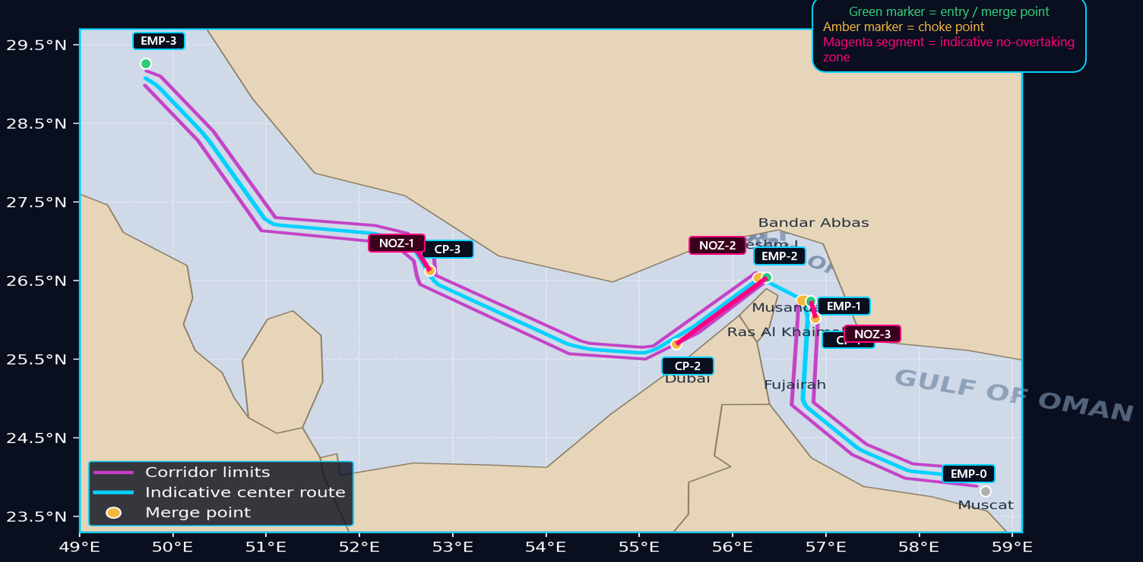
Figure A1. Indicative transit corridor overview.

Appendix B — Indicative Coordinates and Points of Interest
! | Coordinates and points of interest are indicative only. Verify against current official charts, NAVTEX, and relevant notices to mariners before use.

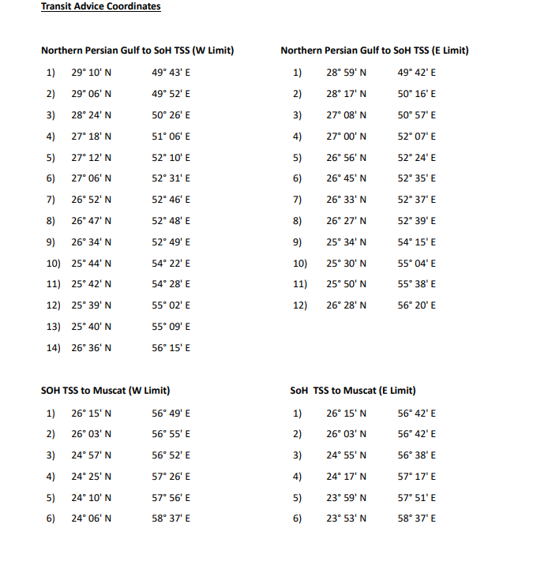
Figure B1. Source-draft coordinate extract.

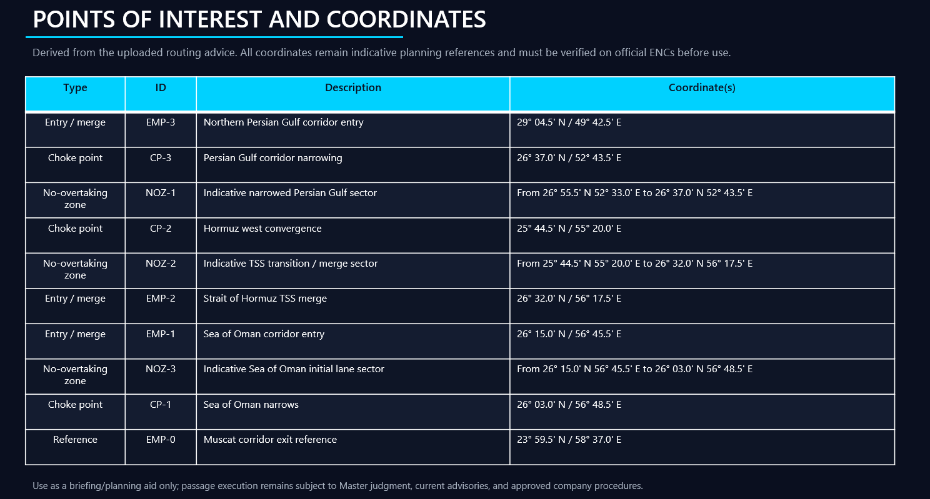
Figure B2. Source-draft points of interest and coordinates.

Appendix C — Example Threat and Hazard Matrix
This example matrix is intended as a member planning aid and should be adapted to vessel type, cargo, timing, route, and current official reporting.

Assessment method: Risk assessed using a 5×5 matrix. Likelihood: 1–5. Severity: 1–5. Total Risk Score = Likelihood × Severity.
Risk bands: Low (1–4) | Medium (5–9) | High (10–14) | Extreme (15–25)

Hazard | Risk Level | Typical Drivers | Potential Impact
Missile / Drone Attack | Extreme | Regional conflict cycles; proximity to threat launch areas | Direct strike on hull, cargo area, bridge, or machinery; fire/explosion; fatalities or serious injury; loss of propulsion/steering; pollution; abandonment risk; major casualty.
Naval Mine Threat | Extreme | Choke-point geometry; uncertainty over recent incidents | Catastrophic underwater damage; flooding and structural failure; loss of life; pollution; immobilisation in confined water.
GNSS Jamming / Spoofing | Extreme | Confirmed regional interference patterns | False position indication; TSS deviation; collision or grounding risk.
AIS Target Overload | Extreme | High concentration of vessels released simultaneously | Loss of situational awareness; late collision-avoidance action; bridge-team overload.
Close-Quarters Collision | Extreme | Convoying and clustering under surge conditions | Hull/tank damage; fire or spill; injury/fatality; loss of manoeuvrability; multi-vessel casualty.
Erratic Manoeuvring | Extreme | Stress-driven helm/engine changes by surrounding vessels; mixed vessel types | Unpredictable traffic picture; sudden close-quarters situations; chain-reaction alterations.
Forced CPA Reduction | Extreme | Compression at merge points and choke sectors; overtaking in constrained water | CPA falling below limits; increased collision probability; abrupt avoiding action required.
Fast Boat / Asymmetric Attack | High | IRGC tactics history | Harassment; forced course alteration; distraction of bridge team; escalation to collision or attack.
Boarding / Interference | High | Opportunistic risk | Threat to crew safety; disruption of bridge/engine operations; forced deviation or detention.
AIS Manipulation / False Targets | High | Hybrid information environment | Misleading traffic picture; delayed avoidance decisions.
Congestion | High | Commercial pressure; variable ship speeds and manoeuvring characteristics | Reduced sea room; unstable traffic flow; near-miss and collision exposure; crew fatigue.
TSS Violation Cascade | High | Late entry/exit from traffic lanes; spoofing; poor position confidence | Multi-vessel COLREG/TSS non-compliance; secondary crossing conflicts; grounding risk.
Grounding | High–Extreme | Reduced sea room; track displacement under traffic pressure | Hull damage; pollution; loss of manoeuvrability.
Legal Non-Compliance | Medium | Flag/coastal-state directions; war-risk notification and reporting obligations | Breach of instructions; insurance and liability exposure; PSC action; charterparty dispute.

Appendix D — Pre-Transit Preparation Checklist

Office Level
✓ | Action Item
☐ | Daily threat brief issued and distributed to vessel
☐ | Naval advisories consolidated (UKMTO, MSCIO, NAVCENT, EUNAVFOR)
☐ | Transit window confirmed or delayed based on threat picture
☐ | Contingency routing pre-approved by DPA and Head of Security
☐ | AIS policy defined and communicated to Master: If AIS OFF — inform UKMTO and MSCIO of ship position every 2 hours; If AIS ON — consider limiting transmitted data to identity, position, course, speed, navigational status, and safety information
☐ | Insurance, war-risk, and charterparty positions confirmed
☐ | Tug availability in transit area determined
☐ | Salvage resources assessed; additional coverage sought if required
☐ | Non-essential personnel disembarkation confirmed
☐ | Pre-transit guidance issued to Master

Shipboard Level — Navigation
✓ | Action Item
☐ | Passage plan reviewed: wheel-over positions, parallel indexes (both sides), manual fix intervals ≤6 min, abort points defined
☐ | Radar ranges optimized (3/6/12 nm split)
☐ | Echo sounder monitored and operational
☐ | Paper charts obtained as back-up; OOWs and Master confirmed proficient in position plotting
☐ | GNSS cross-check active (gyro / log / radar)
☐ | Dead reckoning plotting continuous
☐ | Spoofing detection checklist reviewed
☐ | GNSS Failure Drill conducted — findings logged

Shipboard Level — Security, Machinery & Emergency
✓ | Action Item
☐ | ISPS Level 3 raised (or as directed by Flag Administration)
☐ | Deck lighting confirmed operational; blackout plan ready
☐ | All external access secured
☐ | Main engine on standby readiness
☐ | Steering redundancy tested; emergency steering operational
☐ | Emergency generator ready and tested
☐ | SSAS tested and operational
☐ | Emergency communication plan prepared; pre-drafted messages ready
☐ | Communication plans displayed at all external comms stations, muster point, and citadel
☐ | Drills completed: Fire, Abandon Ship, Steering Gear, GNSS Failure, Security (co-ordinated attack)
☐ | Ship Security Plan reviewed and amended as required following pre-voyage risk assessment

Appendix E — Transit Execution Advice

A. Bridge Manning
- Master on bridge for full transit duration — no relief except under exceptional circumstances
- Additional OOW assigned plus dedicated radar plotter
- Helmsman on manual steering throughout

B. Navigation Execution
- Remain strictly within the TSS; maintain maximum feasible distance from the coast of Iran
- Join TSS early — not at choke points
- Avoid overtaking before entry; avoid crossing traffic near merge zones
- Maintain maximum safe manoeuvring speed
- Delay entry if >60 AIS or radar targets visible within 12 nm
- Target CPA ≥1.5 nm minimum
- Maintain minimum 30 nm standoff from U.S. military vessels
- Avoid course alterations >10° unless essential
- Avoid speed reduction in narrow sectors

C. Communications
- Continuous VHF watch on Ch 16 and regional working frequency. Minimise unnecessary transmissions.
- If hailed or emailed by Iranian forces and directed to divert or submit voyage information: ignore and continue passage if safe. Do not comply — compliance may assist hostile targeting. Report to UKMTO and NAVCENT NCAGS immediately.
- Prefer email or secure satellite phone for sensitive communications
- Maintain social media hygiene — no photographs or position details posted
- Report to UKMTO / MSCIO per agreed reporting schedule
- AIS ON — restricted data if advised by CSO

D. Surge Traffic Mode

SURGE TRAFFIC MODE — Activate if any of the following are detected:
• AIS targets > 60 within 12 nm radar scale
• Radar contacts > 60 within 12 nm
• CPA instability affecting ≥ 3 contacts simultaneously
• Continuous VHF congestion indicating saturated traffic

Master Checklist before entry in surge conditions:
• Is traffic stabilized? • Is CPA manageable?
• Is radar picture clean? • Is crew ready?

If any answer is NO → WAIT for conditions to improve.

Appendix H — Bridge Quick-Reference Card
STRAIT OF HORMUZ TRANSIT — BRIDGE QUICK-REFERENCE CARD

BEFORE ENTRY | DURING TRANSIT | IF THREAT OCCURS
☐ Threat brief completed  ☐ Master on bridge  ☐ GNSS cross-check active  ☐ Parallel indexes set  ☐ Security level raised  ☐ SSAS tested  ☐ AIS policy confirmed | NAVIGATION  • Manual steering at all times  • CPA ≥ 1.5 nm minimum  • Fix every ≤ 6 minutes  • Continuous radar sweep  • Visual lookout reinforced  SECURITY  • Crew inside accommodation only  COMMS  • VHF Ch 16 + local channel  • Position reporting active | FAST BOAT:  ➡ Increase speed + alter course early  DRONE / MISSILE:  ➡ Alarm + hard manoeuvre + shelter crew  GNSS FAILURE:  ➡ DR + radar only navigation  BOARDING:  ➡ SSAS + Ship Security Plan + Citadel

GOLDEN RULES
✔ Stay inside TSS ✔ Avoid unpredictable manoeuvres ✔ Maintain maximum readiness ✔ Report early — act early

