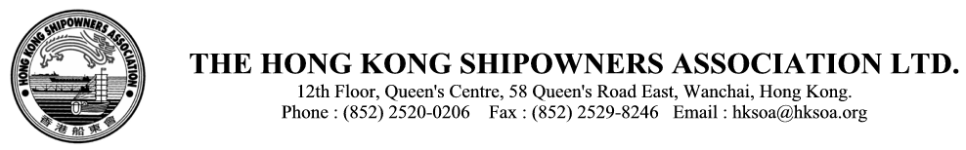

Cir. Ref: A(26) xxx

TO ALL MEMBERS xx Sept 2026

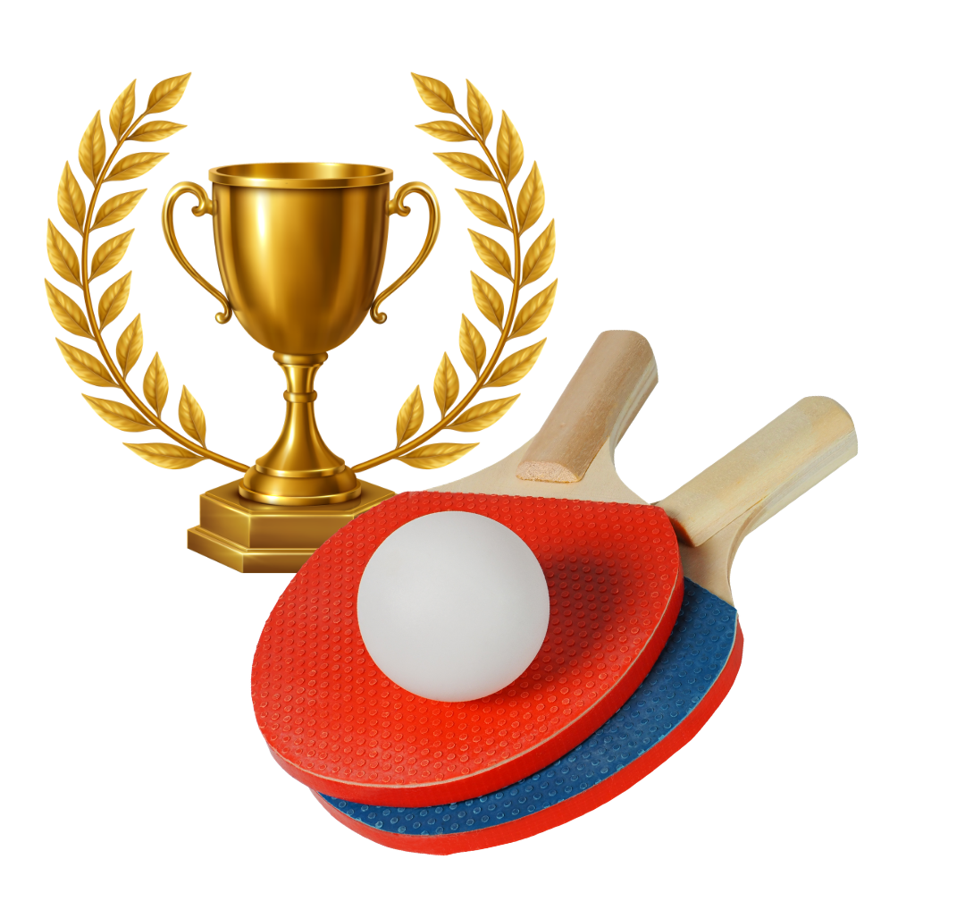

HKSOA
Table Tennis Tournament
and Fun Days
+ Celebration Dinner

The celebrations begin! To kick off our 70th-anniversary milestone, we are excited to host the 4th Table Tennis Tournament and Fun Days, with the 70th Anniversary Cup and medals presentation ceremony, and by a big 'Celebration Dinner' for even more fun and networking.

Date: Wednesday, 13 January 2027 (Day 1)
Thursday, 14 January 2027 (Day 2)

Time: 2pm to 10pm (Day 1)
2pm to 10pm (Day 2)

Venue: South China Athletic Association Sports Hall
Royal Cascade Chinese Restaurant 御瀧軒(“celebration dinner” on Day 2)

Celebration dinner – Early bird: HK$200/head – on or before 1 December 2026
Original Price: HK$300/head – Tickets are available at the reception counter in the Sports Hall prior to the dinner
(free-of-charge for all players in semi-finals and the first four winning cheering teams)

Programme rundown (tentative, subject to change)

13 January 2027 (Wednesday)

- Fun day for all - all are welcome to join, for fun and practice with the HKSOA coaches, from 2pm to 9pm.
- Preliminary rounds for Men’s Individual categories EXCEPT Men’s Singles (Senior)
- Preliminary rounds for Women’s Singles and Women’s Double from 6pm to 9pm.

14 January 2027 (Thursday)

- Fun day for all - all are welcome to join, for fun and practice with the HKSOA coaches, from 2 pm to 5pm.
- Quarter-final, Semi-final and Final rounds for Individual
- Men’s Singles (Senior) competition
- Group competition and Elites Group Competition
- Awards presentation ceremony at 6pm, followed by the Celebration Dinner.

Competition Categories

- Individuals Competition 個人賽

Men’s Singles (Youth) (aged under 40)
Men’s Singles (Master) (aged 40 to 59)
Men’s Singles (Senior) (aged 60 or above) – all games on Day 2 only
Men’s Doubles
Women’s Singles
Women’s Doubles

Notes:
- Every member company may nominate not more than 8 players in total for all the six games. Free-of-charge for all these 8 players.

- For additional players from the same company, the fee is HK$300 per player.

- All the players in this category may also represent their companies to take part in the Group Competition category or the Elites Group Competition category.

- All semi-finalists will be awarded a 70th-anniversary commemorative medal.

- Group Competition 團體賽

Men’s Singles x 4 – all games on Day 2 only
Women’s Singles x 1 – all games on Day 2 only

Notes:
- Every member company may nominate not more than 8 players in total for all the five games. Free-of-charge for the 1st team of the company.

- For additional teams from the same company, the fee is HK$4,000 per team.

- All the players in this category are not permitted to take part in the Elites Group Competition category.

- If the program schedule does not permit, the third-place playoff might be skipped. In that case, both teams that lost in the semifinals will be named second runner-up.

- All semi-finalists will be awarded a 70th-anniversary commemorative medal.

- Elites Group Competition 團體精英賽

Men’s Singles x 3 – all games on Day 2 only
Women’s Singles x 1 – all games on Day 2 only
Men’s Doubles x 1 – all games on Day 2 only

Notes:
- The six winner company teams of the previous three TTTs will be invited to join the Elite Group Competition for the HKSOA 70th Anniversary Cup 香港船東會七十週年紀念盃 , with no more than 8 players in total for all the five games. These companies are: Anglo-Eastern, BG Shipping, Celsius Tech, COSCO Shipping, Hong Kong Ming Wah, and Wallem Group. The fee is HK$6,000 per team.

- For other member companies that wish to join this Elites Group Competition category, the fee is HK$10,000. No more than 8 players in total for all the five games.

- If the program schedule does not permit, the third-place playoff might be skipped. In that case, both teams that lost in the semifinals will be named second runner-up.

- All Participants will be awarded 70th-anniversary commemorative medal. The champion, 1st runner-up, and the 2nd runners-up will be awarded 70th-anniversary commemorative trophies.

Competition Rules

- For all matches, the winner is the best of three games. A game is won by being the first player to win 11 points, and be at least two points ahead of the opponent. If both players have won 10 points, then the first player to get a two-point lead wins the game.

- Every group in the Group competition category shall nominate only players who do not take part in the Individual competition categories.

Please complete and return the attached reply form by 1 November 2026 to enable us to assess attendance.

Don’t miss the fun !
Don't miss the 70th-anniversary commemorative medal and Trophy!

To: The Hong Kong Shipowners Association

Fax: 2529-8246 or Email : sports@hksoa.org

Association Table Tennis Tournament and Fun Days, 13 – 14 January 2027
3/F Sports Hall, South China Athletic Association, Caroline Hill Road, Causeway Bay, Hong Kong

- Individual Competition

The following players will join the Individual categories.

(Please tick the right boxes. Every member company shall nominate not more than 8 players, in total, for all the six categories)

All semi-finalists will be awarded a 70th-anniversary commemorative medal.

 | Name | Men’s Singles (Youth) | Men’s Singles (Master) | Men’s Singles (Senior) | Men’s Doubles | Women’s Singles | Women’s Doubles
1
2
3
4
5
6
7
8
***Additional players will be charged at HK$300 per player
9
10
11
12
13
14
15
16
17
18
19
20

- Group Competition
The following players will join the Group categories.

There are Five matches for each team in each round: 4 x Men’s Single and 1 x Women’s Single. There are no age restrictions for either of them. Each team may decide, on the spot, on the representatives to play in the different matches and rounds.

All semi-finalists will be awarded a 70th-anniversary commemorative medal.

Team A |  | Team B* |  | Team C*
 |  | ***additional team will be charged at HK$4,000 per team |  | ***additional team will be charged at HK$4,000 per team
Mr./Ms. |  | Mr./Ms. |  | Mr./Ms.
Mr./Ms. |  | Mr./Ms. |  | Mr./Ms.
Mr./Ms. |  | Mr./Ms. |  | Mr./Ms.
Mr./Ms. |  | Mr./Ms. |  | Mr./Ms.
Mr./Ms. |  | Mr./Ms. |  | Mr./Ms.
Mr./Ms. |  | Mr./Ms. |  | Mr./Ms.
Mr./Ms. |  | Mr./Ms. |  | Mr./Ms.
Mr./Ms. |  | Mr./Ms. |  | Mr./Ms.

- Elite Group Competition
The following players will join the Elite Group categories.

There are Five matches for each team in each round: 3 x Men’s Single, 1 x Women’s Single and 1 x Men’s Doubles. There are no age restrictions for any of them. Each team may decide, on the spot, on the representatives to play in the different matches and rounds.
The six winner company teams of the previous three TTTs will be invited to join the Elite Group Competition for the HKSOA 70th Anniversary Cup 香港船東會七十週年紀念盃 , with no more than 8 players in total for all the five games. These companies are: Anglo-Eastern, BG Shipping, Celsius Tech, COSCO Shipping, Hong Kong Ming Wah, and Wallem Group. The fee is HK$6,000 per team.
All Participants will be awarded 70th-anniversary commemorative medal. The champion, 1st runner-up, and the 2nd runners-up will be awarded 70th-anniversary commemorative trophies.
***Other member companies are also welcome, with a charge of HK$10,000 per team.

Elite Group Competition
Mr./Ms.
Mr./Ms.
Mr./Ms.
Mr./Ms.
Mr./Ms.
Mr./Ms.
Mr./Ms.
Mr./Ms.

Company Name | :
Email | :
Contact Person | : |  | Tel | :
Notes:

- Please complete and return the enrolment form by 1 November 2026.

- If you would like to change the names of players after submission of this enrolment form, please inform the Association secretariat at sports @hksoa.org not later than 18 December 2026.

- The Association secretariat will draw lots on the game order and make announcements about the logistics in due course.

